**EDA on Bonus**

It’s a numeric variable with sample mean = 145.7053, sample variance = 17146.85

The histogram of Bonus is

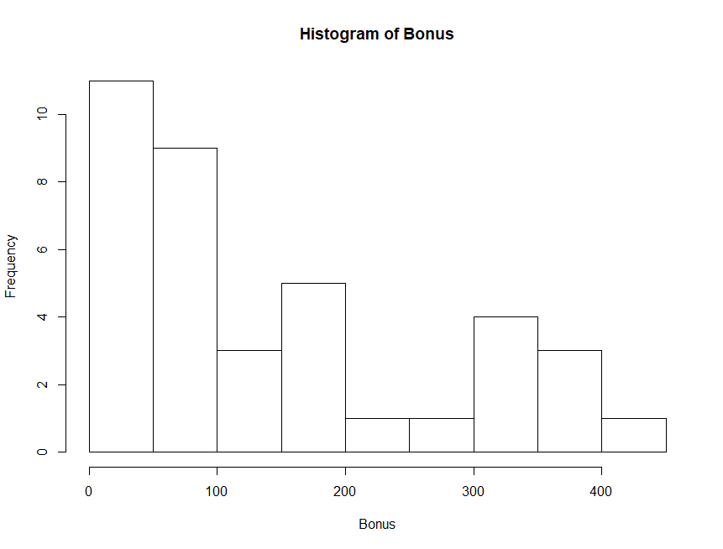

Histogram shows that the distribution is not symmetric.

Five number summary of Bonus is

|  |  |  |  |  |
| --- | --- | --- | --- | --- |
| Min. | 1st Qu. | Median | 3rd Qu. | Max. |
| 0.5 | 46.5 | 93.35 | 196.72 | 439.6 |

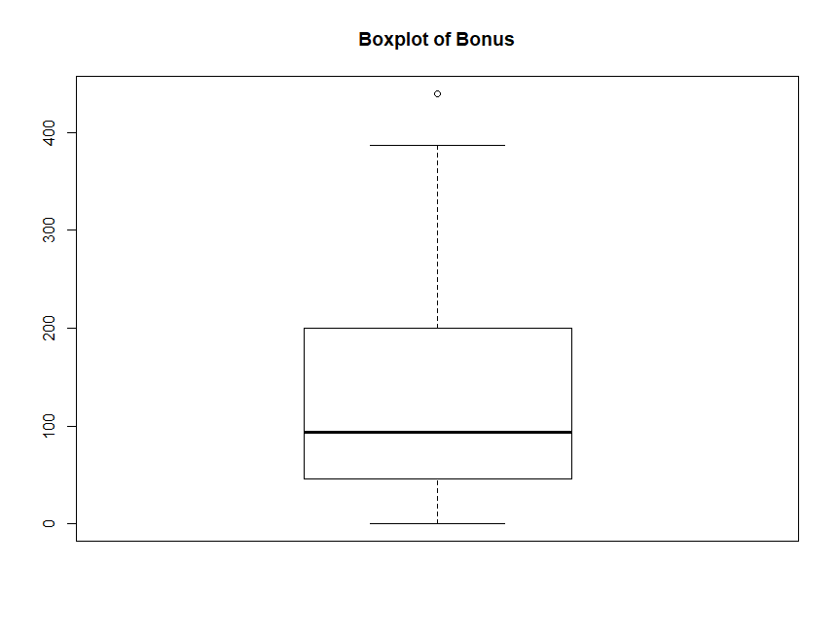

**EDA on Entitlement**

It’s a numeric variable with sample mean = 660.8146, sample variance = 82046.76

The histogram of Entitlement is

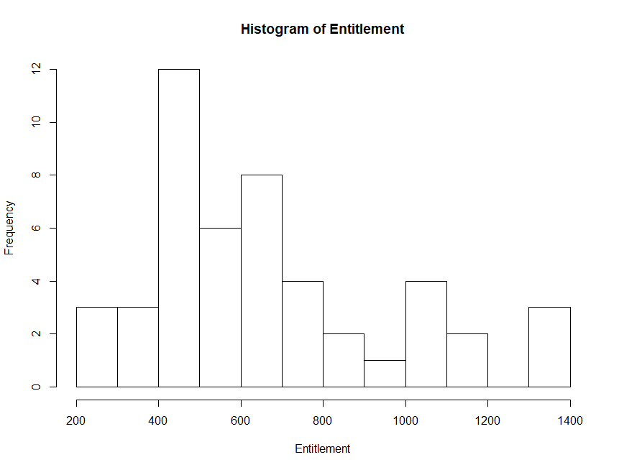

Histogram shows Entitlement is somewhat symmetric

Five number summary of Entitlement is

|  |  |  |  |  |
| --- | --- | --- | --- | --- |
| Min. | 1st Qu. | Median | 3rd Qu. | Max. |
| 265.2 | 447.8 | 598.8 | 780.2 | 1310.6 |

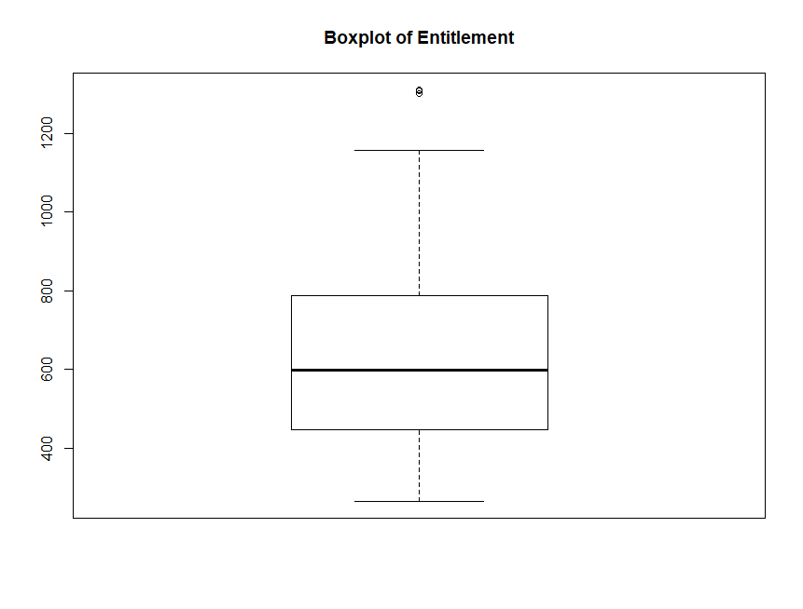

**Normality Test on Bonus**

The Q-Q plot of Bonus is

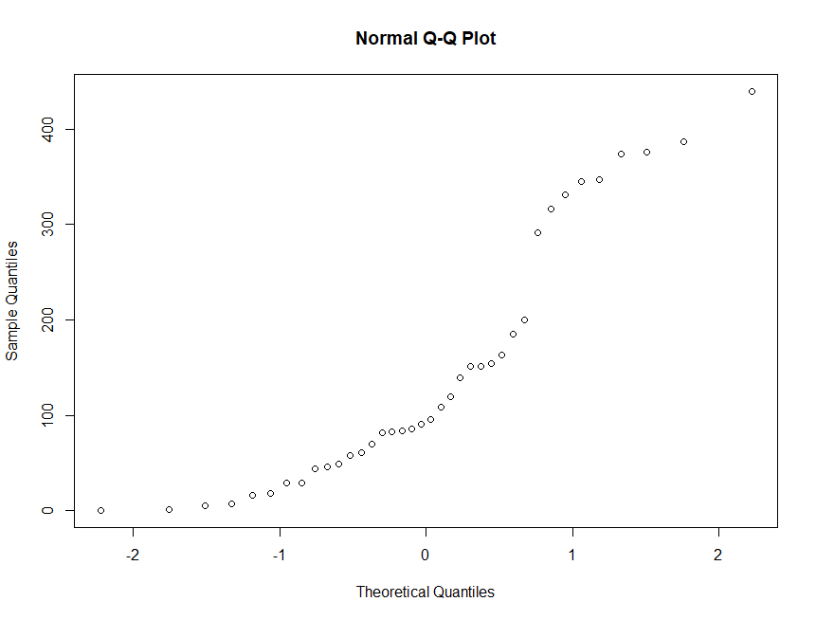

It doesn’t show a 45 degree line.

Shapiro Wilk test gives a p-value of 0.0003017 so we can reject the null hypothesis that Bonus is normally distributed.

**Assignment Answers on Bonus**

Sample mean of Bonus = 145.7053

1. **Assuming variance unknown and non-normality a 95% confidence interval of mean for Bonus is (105.4421, 188.35)**
2. **A hypothesis test for the mean of Bonus equal to 30 vs not equal to 30 is rejected with a**

**p-value = 2.575e-07 (Confidence Intervals also indicate )**

Sample Variance of Bonus is = 17146.85

**4. 95% confidence interval for the variance of Bonus is (9964.57,** **22760.77)**

**Normality test on Entitlement**

The Q-Q plot of Entitlement is

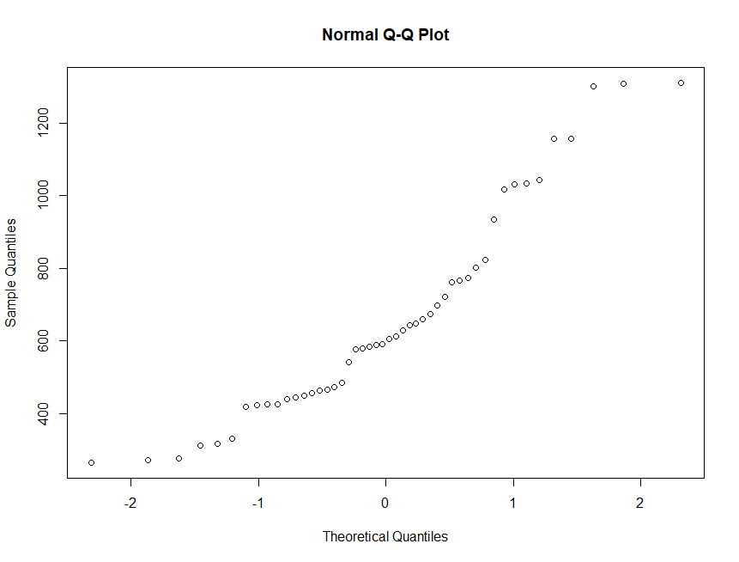

Which does not show a 45 degree line.

Shapiro Wilk test gives a p-value of 0.002539 so we can reject the null hypothesis that Entitlement is normally distributed.

**Assignment Answers on Entitlement**

Sample mean of Entitlement = 660.8146

1. **Assuming variance unknown and non-normality a 95% confidence interval of mean for Entitlement is (583.5146,** **741.9667)**

**3. A hypothesis test for the mean of Entitlement less than or equal to 1000 vs greater than 1000 resulted in a p-value =1 so Null hypothesis is accepted (Confidence Interval values are also supportive of Null Hypothesis)**

Sample Variance of Entitlement is = 82046.76

**95% confidence interval for the variance of Entitlement is (49408.42,** **111236.1)**